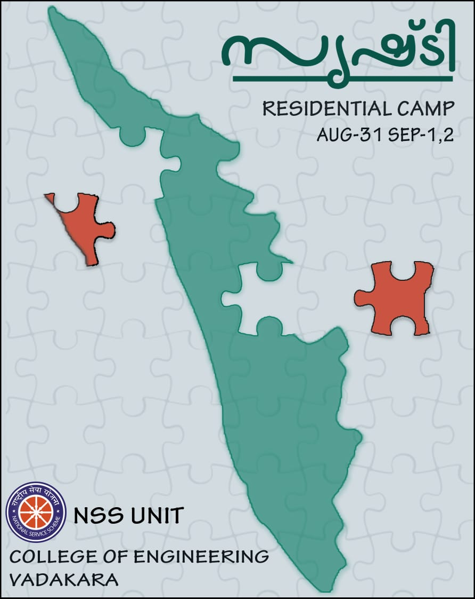

**SRISHTI CAMP**

A camp was conducted under the chief minister flood relief campaign called “SRISHTI” along with NSS unit and support from assistant engineers of various panchayaths (Maniyur ,Changaroth,Cheruvannur,Velom) held during 31st August 2018 to 2nd September 2018.Around 300 students attended the camp.

DAY 1:

First day,the camp started at 9.00am.The NSS students were asked to attend morning session for making the necessary arrangements for camp.The students registration started up by 2.00 pm.The inauguration ceremony started by the time 3.00pm .The welcome speech was given by Ashitha T.During the session NSS co-ordinators as well as Babitha miss, Vijayan sir gave their talks.Inauguration made by Panchayath President Jayaprabha and finally vote of thanks was given by Adil and official inauguration was done.

Day 1 ended with a class conducted by students from our own college,who have previously attended the camp,on how to conduct the survey. They shared their knowledge about the camp with us,which equipped other students to conduct the survey in an efficient manner by filling the form given to us by NFRA(NSS flood relief activity), that was conducted during 27th August 2018 and 28th August 2018 in REC, Chathamangalam. The students were divided into different groups for doing their survey.

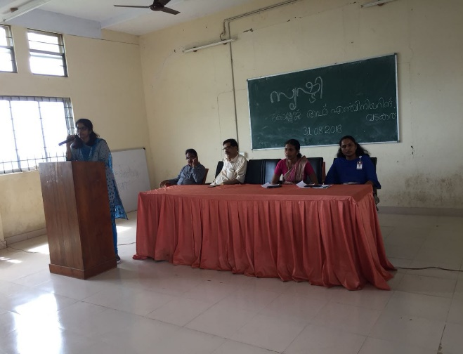

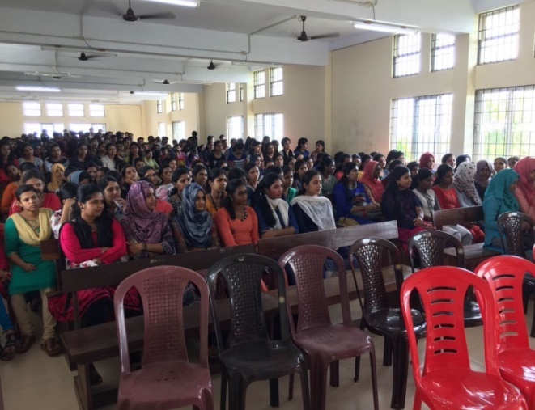

DAY 2:

The second day started up at 9.00 am, at that day we visited two panchayaths, ie, Maniyur and Cheruvannur .Among the 250 students which were divided into different groups assigned to different duties.

During our visits, we were asked to collect information about losses and click pictures of major losses for the panchayaths to provide fund for them. Some houses were badly effected they no longer can be used for accommodation. In some houses, there were big cracks on their walls, floors and roofs and at some places minor cracks were also found. We were asked to calculate the crack area for estimation.All over estimation is also calculated by the students and gave to Assistant Engineer of particular panchayaths.

In some places, the duty assigned to us to chlorinate the wells which got contaminated due to flood water.The septic tank and well water seems to be combined in places.

During surveying there was complete co-operation from the panchayaths, especially the ward members and Assistant Engineer of that area.

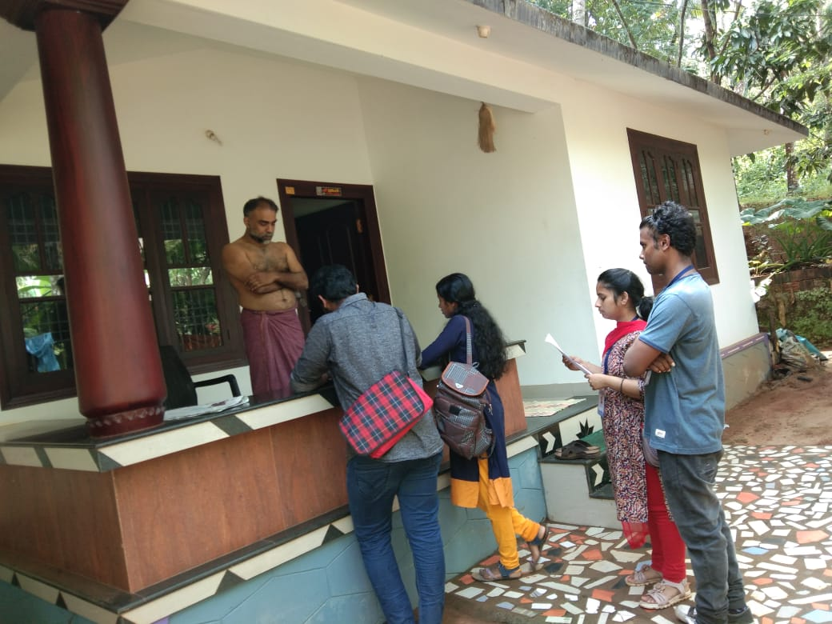

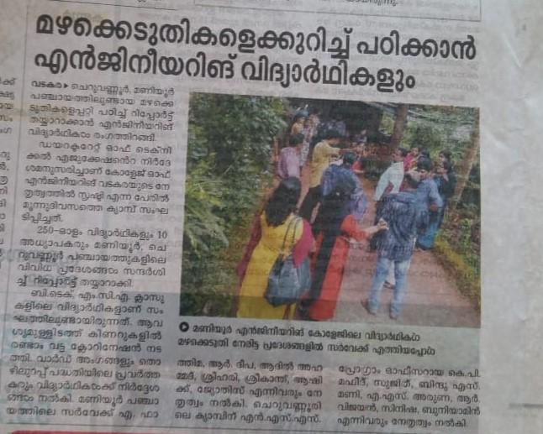

DAY 3:

The third day also the camp started up at 9.00am and we visited the other two pancahyaths ,Velom and Changaroth. The Changaroth panchayath was visited by boys alone.The same procedure was repeated on day 3 also.

The information gathered by different groups were combined and data entry was also done on the same day by the remaining students.The camp ended in a good manner.

